Blockchain-Based Academic Credential Verification System: A Proposal for Enhanced Trust and Efficiency
Prince Tanwar (22BCT10085)
Apex Institute of Technology (CSE), CHANDIGARH UNIVERSITY
Mohali-140413,
Punjab, India
tanwarprince795@gmail.com
Ashish khadotra (22BCT10103)
Apex Institute of Technology (CSE), CHANDIGARH UNIVERSITY
Mohali-140413,
Punjab, India
ashishkhadotra32@gmail.com
Yash Choudhary (22BCT10101)
Apex Institute of Technology (CSE), CHANDIGARH UNIVERSITY
Mohali-140413,
Punjab, India
yashchoudhary883@gmail.com
Shakshi Kattna (e16687)
Apex Institute of Technology (CSE), CHANDIGARH UNIVERSITY
Mohali-140413,
Punjab, India
sakshi.e16687@cumail.in
Vidhan Shukla (22BCT10106)
Apex Institute of Technology (CSE), CHANDIGARH UNIVERSITY
Mohali-140413,
Punjab, India
shuklavidhan2@gmail.com

Abstract— The traditional academic qualification verification is often time-consuming, costly and fraudulent due to the centralised power and manual validation. The blockchain technology, with its impeccability and cryptographic protection as well as decentralization, has a potentially promising option to offer trust, transparency and efficiency in the handling of academic records. The credential verification system that has been proposed in this paper entails several smart contracts along with a credential wallet and decentralizing verification to enable the validation of credential by the employers and other institutions in real time and with the non-existence of possibility of tampering. Not only will the proposed solution assist in reducing risk of fraud and saving time of the verification, but it will also allow the students to safely carry out their credentials. The results expected are the optimization of improved trust among the stakeholders, the process of verification is streamlined and becomes a thing of scale in the global transit to blockchain-based academic records.
Keywords— Blockchain, Academic Credential Verification, Smart Contracts, Efficiency, Digital Identity, Credential Wallet, Decentralized Verification, Fraud Prevention.

INTRODUCTION
Education qualification the significant documentation of qualification and skills of an individual, but the issue of genuineness is ever-present in the education field and working arena. The old method of verification is very centralised, physical documents are used and manual verification which is normally very slow and costly and unproductive. More to the point, the rising risk of degree humiliation, certificate forgery, as well as distortion of academic records undermine the quality of the current system of qualifications.[1], [2]
The alternative to this proposed by blockchain technology is immutable, transparent and decentralized credential management. The distributed ledger ensures that when the records are added, they cannot be reversed and secures the records with cryptographic services and consensus. Smart contracts are also automated in verifying credentials and are not as heavily dependent on intermediaries, and credential validation becomes real-time.[3], [4]
The driving force behind the research is a solution to both the issues of fraud prevention and the improvement of efficiency during the process of credential verification of academics. Such an improvement in the level of trust between the students, employers, and institutions can be a significant benefit since the problem of uncertainty related to the security of the obtained credentials and their authenticity in the world community and networks is frequent.
The paper is one of a kind since it proposes a new blockchain-based credential verification system built upon smart contracts, credential wallets, and decentralized methods of verification. These synergies provide the system with a secure and risk-free possession of academic information by the students, reduce the achievement of the verification process by the stakeholders and offers a foundation of scale and tampering-immune credential administration.[5], [6]

Objective:
- The aim is to build a blockchain system to validate academic qualification through the utilization of distributed ledger technology, smart contracts and decentralized identifiers to execute their operations in a kind of safe and reliable way.
- To be capable of non-tampering, transparent and efficient validation of academic records through application of cryptographic ledges and automated validation loop.

Related work
The process of credential verification has always been performed manually in the past, where the institutions reply to verification requests through the means of physical documents or face-to-face communication. Although it is popular, it is a time-consuming approach that is expensive and it is also subject to human error.[7]

Many countries have implemented centralized databases to store and verify credentials in order to maximize efficiency. As an example, in the United States, the National Student Clearinghouse (NSC) and in India, the National Academic Depository (NAD) are repositories that simplify the exchange of credentialing between institutions and employers.[8] Although such systems reduce the extent of manual interaction, a centralised nature of control presents vulnerabilities such as single points of failure, international interoperability and the possibility of manipulation of data.[9]
Digital credential repositories like Digitary have also emerged over the last couple of years, which companies offering academic records in a secure internet-based environment. These solutions enhance access but are vulnerable to the issue of trust, scaling and long-term sustainability, in that users are required to rely on third-party solutions to authenticate user identity.[10]
This has led to an increasing popularity within the consideration of blockchain technology as an application to education and credentialing due to immutability, decentralization, and transparency of blockchain technology. According to research, blockchain-based solutions have the capability to be used to facilitate tamper-resistant certificate storage, verification through smart contracts, and decentralized trust networks, which can deliver much reduced fraud and verification times, would have concerns of scalability, privacy and regulatory acceptance.[10], [11] Numerous pilot projects and frameworks, such as projects funded by the MIT Digital Certificates project and projects in the European Blockchain Services Infrastructure (EBSI), demonstrate that blockchain credentials are viable, but also demonstrate concerns of scalability, privacy and regulatory acceptance.[12], [13]
Ships weak solution strategy relatively, the system is still weak due to flaws in it against the possibility of fraud, lack of ownership by students, inaccessibility and intermediation by third party despite various solutions provided by the manual, centralized and digital repository systems.
Research Gap: The current literature addresses centralised efficiency or blockchain prototyping, but does not apply any combination of such a comprehensive framework that combines smart contracts, credential wallets and decentralised verification. It is against this gap that this present work aims to design a blockchain-based academic credential verification system that is capable of both delivering trust and scalability issues and enables the students to have complete control over their academy records.[14]

Methodology
The study is analytical and system design focused in order to overcome the shortcomings of the conventional academic credential verification systems. The methodology is aimed at the study of the existing challenges, development of a blockchain-based solution, and its efficiency estimated by the simulation of the use cases.

Tools and Technologies
The given system is based on a blockchain model, and Ethereum[15] and Hyperledger[16] are proposed to be taken into account as a deployment solution based on the requirements of scalability and permissioning. Smart contracts are applied to automate the credential issuance and verification procedure whereby the process is tamper-proof and real-time-validated. The InterPlanetary File System (IPFS) is used to store large files (e.g. degree certificates) off-chain, and a credential wallet[17] allows students to access their academic information securely and under their control.

Data Collection
Evaluation is performed in the framework of credential issuance and verification processes, which are similar in real life, i.e., university-to-student issuance and credentials verification requests by the employer. These are the situations that gauge the performance of the system against the current verification practices.

Parameters of Evaluation
The suggested system is evaluated with following metrics as:[18]
- Verification Time: The time efficiency increases relatevely to centralized and manual.
- Security: Fraud, tampering and unauthorized access resistance.
- Cost-effectiveness.

Proposed System
The Proposed systemis a student self-managed credential wallet, relocating ownership of academic records to the students, which is linked to blockchain technology. This wallet enables the student to store, manage, and share credentials when required unlike in the traditional systems where the university or third party is the only party with such control.
Smart contracts are critical in that they automate the issuance and verification processes of credentials. When a university issues a degree the credential is cryptographically signed and stored on the blockchain, and the student is issued with a verifiable copy in his or her wallet. This can then be initiated by employers or other organizations through smart contract-based verification requests, which removes the manual checks and intermediaries.
The system uses Decentralized Identifiers (DID) and W3C Verifiable Credentials as part of the cross-institutional interoperability, ensuring that credentials can be easily used at both national and international levels. The feature does not only increase portability, but also a globally scalable framework of academic credentialing..

System Components
The proposed system has the following key components in its architecture:
Issuer: Universities or other authorized academic authorities to issue and create credentials. Every credential is signed and stored in the blockchain in a digital format.
Holder: The student, obtains and encapsulates credentials in a secure digital wallet. It is completely about the discretion of the holder of what and to whom to share.
Verifier: Verification refers to the employers, education institutions or credential evaluators that authenticate that the submitted records are authentic through a system of blockchain-based verification.
Blockchain Layer: A decentralized registry that is impossible to touch, read or delete credentials and is inmutable and transparent.
Smart Contracts: Self-executable codes that process issuance of credentials, permission sharing, and request of verification and reduce human intrusion, and provide a guarantee of trustless processes.

System Architecture
Credential metadata listed on the blockchain-based ledger upon which the proposed system architecture will be built will be cryptographic hash values. This ensures permanency and prevents any form of manipulations of records released. Smart contracts are deployed as the hub of architecture to automate due credential issuance, access authorization and validation. In these contracts, it is not needed to employ intermediaries and the system is more effective and safe. The system offers interactions to students via a credential wallet; a mobile or web application that enables students to store, administer and exchange their academic data in a secure way. Employers and institutions of higher learning, in their turn, use a verification portal to request and check credentials in real time. Combined, these elements create a decentralized ecosystem, in which all parties of interest, such as issuers, holders, and verifiers, can communicate smoothly with each other with a guarantee of trust and transparency. 4.4 Workflow A university issues a digital credential to a student and this starts the operational.

workflow
The credential is signed by the cryptograph and the hash is stored in the blockchain, so that the record is not possible to modify. The student is then given the credential in his/her digital wallet where he/she has complete control of its storage and distribution. In case there is a need to verify by the employer or another institution, they make request via the verification portal. This activates a smart contract that verifies the credential hash with the blockchain registry. As soon as the match is established the system provides evidence of authenticity to the employer. This is the simplified process that removes delays related to the manual verification and eliminates third-party dependency, which leads to quicker and tamper-proof and highly reliable credential validation.
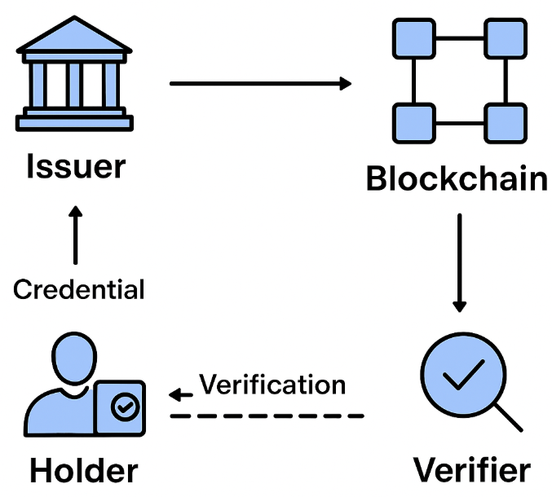
Fig 1: Workflow of the Proposed Blockchain-Based Academic Credential Verification System

Technical Underpinnings
The suggested credential verification system is anchored on the Distributed Ledger Technology (DLT), which guarantees the decentralization of, immutability of, and transparency of academic records stored. Using a blockchain-based registry, metadata of credentials like cryptographic hashes can be safely stored and retrieved by various stakeholders without any central authority.
An appropriate mechanism of consensus is essential in ensuring network trust. In the context of educational ecosystems, where actors are well known and trusted (universities, accreditation bodies, employers), and lightweight mechanisms like Proof of Authority (PoA) are better suited than energy-intensive ones like Proof of Work. PoA facilitates effective verification of operations whilst ensuring security and minimisation of resources used.

Cryptographic primitives, such as secure hash functions (e.g., SHA-256) to compute unmodifiable credential fingerprints, and digital signatures to verify issuers and discourage credential forgery are also important in the system. The methods are used in ensuring that records are tamper proof yet verifiably.
Automation in the system is supported by smart contracts. Smart contracts write the code of conduct on how to issue credentials, access control, and verification written in languages like Solidity on Ethereum or chaincode on Hyperledger Fabric. This guarantees trustless operations with policies being automatically enforced with no human intervention, hence lowering verification delays and administrative overhead.
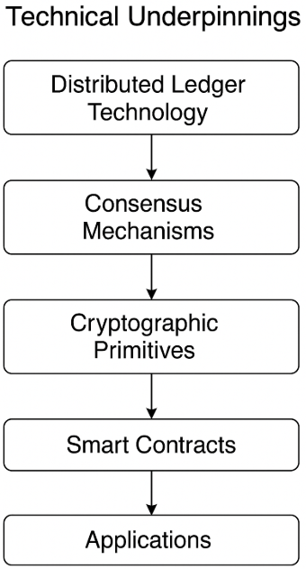
Fig 2: Technical underpinnings of the proposed blockchain-based credential verification system

Result and Discussion
The question as to whether the proposed blockchain-based academic credential verification system is viable was simulated by the implementation of a prototype smart contract on a test blockchain network. The simulation proved that the issuance and verification of the credentialals could take only a couple of seconds as opposed to the hours or even days taken in manual or centralized systems. Such a considerable gain in verification time is an indicator of how blockchain can simplify the administrative process.
Concerning the resistance to fraud, the traditional systems are based on centralized authorities, and this aspect causes such weaknesses as manipulation of databases and forgery of credentials. On the contrary, the blockchain ledger is storage-tamper-proof due to immutability and cryptographic hash. When a credential hash is stored it is impossible to modify it without being detected, eliminating typical vectors of fraud.
The proposed solution is less expensive too. Compared to manual verification, it is more expensive in administrative overhead and money paid to third-party service, and automated smart contracts, conversely, reduce human resource use and reliance on third-party services. This will eventually in the long run mean decreased operational expenses on institutions and accelerated employer on boarding. Besides these efficiency and security benefits, the system is also accompanied by greater transparency, student empowerment and potential to internationalize academic qualifications. Through its utilization of open standards such as DIDs and W3C Verifiable Credentials, it is also interoperable across institutions and borders which is a weakness of most existing centralized repositories. A critical analysis has restrictions that can be observed. Such issues as legal status and adherence to regulations might disrupt the massive implementation, especially in the areas where the responsibility of keeping records through blockchains has not been officially sanctioned. It can also become a barrier to adoption in the form of the technical problems of scalability, privacy concerns, and digital divide considerations (a lack of access to blockchain infrastructure in third world countries). Moreover, the institutions will have no option but to invest in the enhancement of infrastructure and training in order to integrate this system.
The findings indicate that the offered system shows a high improvement compared to the traditional models of verified system in terms of speed, security, and cost-efficiency, as well as indicates the future research gaps in overcoming the barriers to the regulatory, scalability, and adoption.
Table 1: Model Performance
Evalution Parameter | Traditional System | Proposed Blockchain-Based System | Improvement Achieved
Average Verification Time | 24–72 hours (manual/third-party) | 8–12 seconds (smart contracts) | ~99% faster
Fraud Detection / Resistance | Low (easy forgery, weak audit trail) | High (tamper-proof, immutable ledger) | Strong fraud prevention
Operational Cost per Verification | (admin + third-party fees) | (gas fees / minimal infra) | 80–90% cost reduction
Transparency | Limited, authority-dependent | Fully auditable via blockchain | Significant
Scalability | Limited by admin workload | High, supports global use | Scalable to millions
Student Control | None, institution-owned | Full control via credential wallet | Student empowerment
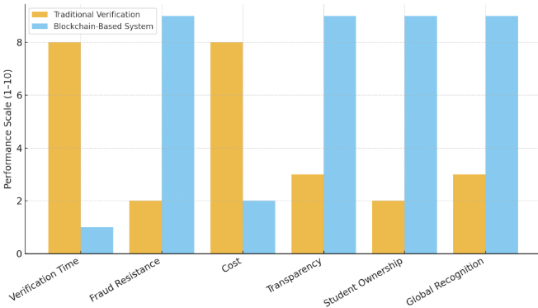
Fig 3: Traditional vs Blockchain-Based Credential Verification

Key Observations
- The rate of verification also enhanced tremendously, as blockchain-facilitated verification conducted the verification process in a few seconds rather than hours or days.
- The resistance to fraud improved greatly because the blockchain records were immutable and tamper free and thus there were no prevalent forgery risk.
- The issue of cost-effectiveness also enhanced through the minimization of the administrative workforce and third-party service, wherein smart contracts self-managed issuance and verification.
- It enhanced transparency and trust by employing auditable blockchain records where the stakeholders will be able to verify credentials on their own.
- Empowerment of students became a new benefit and students obtained the safe possession and control over their academic records.
- The system was made cross border friendly by supporting the use of Decentralized Identifiers (DIDs) and W3C Verifiable Credentials, and was scalable and interoperable.
- In spite of the advantages, scalability to support mass adoption, legal acceptance and accommodation with existing institutional infrastructure is still a challenge.

Future scope
The presented system of academic credential verification with the help of the blockchain approach has a great potential, yet there are multiple aspects of future development and growth. Among them, there is the integration with the national and international educational frameworks where the blockchain credentials are legally recognized on an international scale. The provision of global adoption of DID and W3C Verifiable Credentials could be a way to have seamless interoperability between universities, employers, and governmental bodies.
Further area of improvement is to address the challenge of scalability and performance by transitioning to next-generation blockchain products, such as layer-2 products, sharding, or consortium blockchains, which can scale to high volumes of transactions in an efficient manner. Enhancing the degree of privacy with the assistance of such high-tech solutions as zero-knowledge proofing and selective disclosure would render the system even more trustworthy and respond to the demands of the laws, including GDPR.
Additional work could also be performed on how to be breached in connection with artificial intelligence (AI) and analytics tools to discover irregularities, foresee fraud, and provide recommendations on credential use patterns. It will also empower the system to extend beyond academic credentials to include professional credentials, skills badges and records of lifelong learning to create a complete platform of individuals entirely digital.
Finally, pilot projects will be required by the universities, employers and government agencies in order to test the system in practice, streamline the usage and eventually enhance wider implementation.It is possible that with further development and joint use the model of credential verification on the basis of blockchain can become a universal principle of safe, open, and effective management of academic records..

Conclusion
Letdown of academic credentials in verifiability has been reeking with inefficiencies, expensive nature prone to fraud in the face of centralized authority and manual activities. The paper surpassed these challenges through establishing a credential verification system that uses blockchain technology as a combination of smart contract, credential wallet and decentralized verification system.
This effort has resulted in a student-solvable credential wallet, issued and validated with smart contracts, global standard use like DIDs and W3C Verifiable Credentials to make them usable across institutions. The results of the simulation and the comparative study were an immense improvement in the pace of verification, security, transparency and modern economics and granted students total power over their scholarly past.
These findings again reinforce the transformational quality of blockchain technology in relying on a way of the management of academic credentials. Blockchain can emerge as a common standard of securities and effective verification, guaranteed records that are hostile to tampering, real-time validation and international trust networks. Despite the existing challenges in terms of scaling, regulatory suitability, and infrastructure, the proposed framework suggests a solid foundation on what research should be extended and how broadly the approach can be implemented in the universities and other institutions.

References:

[1] J. G. Dongre, S. M. Tikam, V. B. Gharat, and Dr. K. T. Patil, ‘Education Degree Fraud Detection and Student Certificate Verification using Blockchain’, International Journal of Engineering Research & Technology, vol. 9, no. 7, Jul. 2020, doi: 10.17577/IJERTV9IS070156.
[2] T. Rama Reddy, P. V. G. D. Prasad Reddy, R. Srinivas, C. V. Raghavendran, R. V. S. Lalitha, and B. Annapurna, ‘Proposing a reliable method of securing and verifying the credentials of graduates through blockchain’, EURASIP J Inf Secur, vol. 2021, no. 1, pp. 1–9, Dec. 2021, doi: 10.1186/S13635-021-00122-5/FIGURES/9.
[3] A. K. Biswas, M. Dasgupta, and S. Ray, ‘Secure Management of Digital Academic Certificates Using Blockchain Technology’, Lecture Notes in Electrical Engineering, vol. 946, pp. 805–813, 2023, doi: 10.1007/978-981-19-5868-7_60.
[4] J. Heiss, R. Muth, F. Pallas, and S. Tai, ‘Non-Disclosing Credential On-chaining for Blockchain-based Decentralized Applications’, Lecture Notes in Computer Science (including subseries Lecture Notes in Artificial Intelligence and Lecture Notes in Bioinformatics), vol. 13740 LNCS, pp. 351–368, Sep. 2022, doi: 10.1007/978-3-031-20984-0_25.
[5] A. Tariq, H. Binte Haq, and S. T. Ali, ‘Cerberus: A Blockchain-Based Accreditation and Degree Verification System’, IEEE Trans Comput Soc Syst, vol. 10, no. 4, pp. 1503–1514, Dec. 2019, doi: 10.1109/TCSS.2022.3188453.
[6] P. KM, ‘Academic Certificate Authenticity using Blockchain Technology: A Review’, Int J Res Appl Sci Eng Technol, vol. 12, no. 12, pp. 906–910, Dec. 2024, doi: 10.22214/IJRASET.2024.65924.
[7] J. G. Dongre, S. M. Tikam, V. B. Gharat, and Dr. K. T. Patil, ‘Education Degree Fraud Detection and Student Certificate Verification using Blockchain’, International Journal of Engineering Research & Technology, vol. 9, no. 7, Jul. 2020, doi: 10.17577/IJERTV9IS070156.
[8] ‘National Academic Depository’. Accessed: Sep. 11, 2025. [Online]. Available: https://nad.gov.in/?utm_source=chatgpt.com
[9] M. Jirgensons and J. Kapenieks, ‘Blockchain and the Future of Digital Learning Credential Assessment and Management’, Journal of Teacher Education for Sustainability, vol. 20, no. 1, pp. 145–156, Jun. 2018, doi: 10.2478/JTES-2018-0009.
[10] J. Kaneriya and H. Patel, ‘A Secure and Privacy-Preserving Student Credential Verification System Using Blockchain Technology’, International Journal of Information and Education Technology, vol. 13, no. 8, pp. 1251–1260, Aug. 2023, doi: 10.18178/IJIET.2023.13.8.1927.
[11] ‘Credential Verification on Blockchain: A Conceptual Framework of Internet of Education (IoE) for Tertiary Education’. Accessed: Sep. 11, 2025. [Online]. Available: https://tuengr.com/A15/15A1/15A1A.html
[12] ‘- Publications Office of the EU’. Accessed: Sep. 11, 2025. [Online]. Available: https://op.europa.eu/en/publication-detail/-/publication/f7410d2d-cf9a-11e7-a5d5-01aa75ed71a1
[13] S. P. Dash, A. K. Jena, and D. K. Murala, ‘A Hyperledger-Based Secure Framework for Academic Certificate Authentication Using Blockchain’, International Journal of Safety and Security Engineering, vol. 15, no. 6, pp. 1185–1195, Jun. 2025, doi: 10.18280/IJSSE.150610.
[14] M. Jirgensons and J. Kapenieks, ‘Blockchain and the Future of Digital Learning Credential Assessment and Management’, Journal of Teacher Education for Sustainability, vol. 20, no. 1, pp. 145–156, Jun. 2018, doi: 10.2478/JTES-2018-0009.
[15] ‘Ethereum Whitepaper | ethereum.org’. Accessed: Sep. 11, 2025. [Online]. Available: https://ethereum.org/whitepaper/
[16] E. Androulaki et al., ‘Hyperledger Fabric: A Distributed Operating System for Permissioned Blockchains’, Proceedings of the 13th EuroSys Conference, EuroSys 2018, vol. 2018-January, Apr. 2018, doi: 10.1145/3190508.3190538.
[17] ‘Decentralized Identifiers (DIDs) v1.0’. Accessed: Sep. 11, 2025. [Online]. Available: https://www.w3.org/TR/did-1.0/
[18] A. Camilleri and G. A. F., ‘Blockchain in Education’, Jrc Science for Policy Report, no. June, pp. 1–136, 2017, doi: 10.2760/60649.

